- The bar graph shows the results of spinning the spinner 40 times. Find the experimental probability of the event: spinning a 3 or a 5
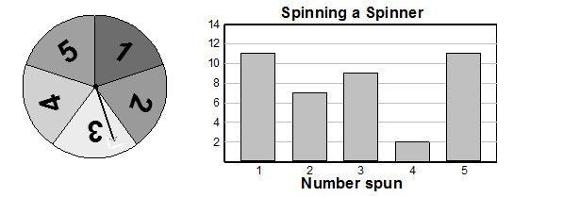

- Kedon Slovis, the Quarterback for USC has 3,500 passing yards in 2019. Their Wide Receiver, Michael Pittman Jr. had 36.4% as many passing yards. How many passing yards did Michael Pittman Jr. have?

3. a. 30 is 30% of what number? b. 45 is what percent of 60?

4. The two spinners shows are being used to play a game. On each turn of the game, the arrows on both spinners are spun. Create a tree diagram to describe all possibly for spinning.
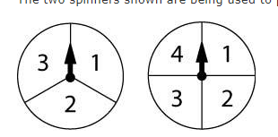

5. The Los Angeles Lakers scored 126 points against the Warriors in game 7 and 114 points against the Boston Celtics in game 55.What is the percent change from game 7 to game 114? Is this an increase or decrease?

6. Courtney buys a pair of jeans at Nordstrom that were originally $90. The jeans are on sale for 35% off. What is the sale price of the jeans? Do not consider sales tax.

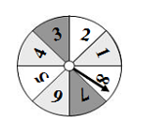7. Use the spinner to determine the probability of: Not spinning a multiple of 4

8. Jesse hired a plumber to install a new shower. The plumber claims that the relationship between the number of hours worked and the total work fee is proportional. If the fee for 10 hours of work is $400, what is the unit rate? Name two other rates that are equivalent.

9. A person who weighs 100 pounds on Earth weighs 8 pounds on Pluto. How much does a person weigh on Earth if the person weighs 20 pounds on Pluto?

10. The following table shows the temperatures last week in Chicago. What is the mean temperature?
Monday | -4˚C
Tuesday | -9 ˚C
Wednesday | 0 ˚C
Thursday | 2 ˚C

