**BOLDED – CALCULATOR OKAY**

**NOT BOLDED – DO NOT USE CALCULATOR**

**Monday**

**1.** Compute the following using mental math strategies, then check with a **calculator.**

**a.** What is 50% of 180? **b**. What is 80% of 250?

**2.** **Hannah’s hourly wage increased from $14.50 to $16.25. What is the percent of change?**

**3. Solve each proportion.**

**a.**  **b.** 

**4.** If the radius of a circle is 15 cm., how long is the diameter? Describe the relationship between radius and diameter (use a visual too!).

**Tuesday**

**1.** Identify the population and a possible sample: The mean number of hours students at LC watch Tik Tok videos.

Population:

Sample:

**2. Solve the following percent problems. Show your work!**

**a. 7 is 70% of what number? b. What is 150% of 87?**

**3.** Simplify using Order of Operations**: a**. (3.3)(15 – 11) **b.** 16 ÷ (32)  (12)

**c.** 48 ÷ (17 – 33) **d.** (–150) ÷ (–50) + (11)(–5)

**Wednesday**

**1.** What is the first step in solving ? _____________________ Solve it: ______________

*Wednesday HW continued on back*

**2.** Solve each equation.

1. 6x – 8 = 28 **b.** –10(x – 19) = –80

**3. If possible, find the radius of a circle where the area of the circle and the circumference of the circle are equal. Is there more than one possible answer?**

**4.** What are the two requirements for a relationship to be proportional? Explain.

**Thursday**

**1.** **Find the area and circumference of the circles with the given information:**

**a. diameter = 10 cm. b. radius = 16 in.**

**2.** Create a graph and rule based on the given table:



|  |  |
| --- | --- |
| x | y |
| -2 | 8 |
| -1 | 4 |
| 0 | 0 |
| 1 | -4 |
| 2 | -8 |

**Rule**: ___________________

**Graph**:

What is the constant of proportionality? _______

**3. A bicycle wheel has a diameter of 60 inches. In one turn, how far does the wheel travel in feet and inches*? (hint: 12 inches in 1 foot; 1 turn equals distance around the circle)***

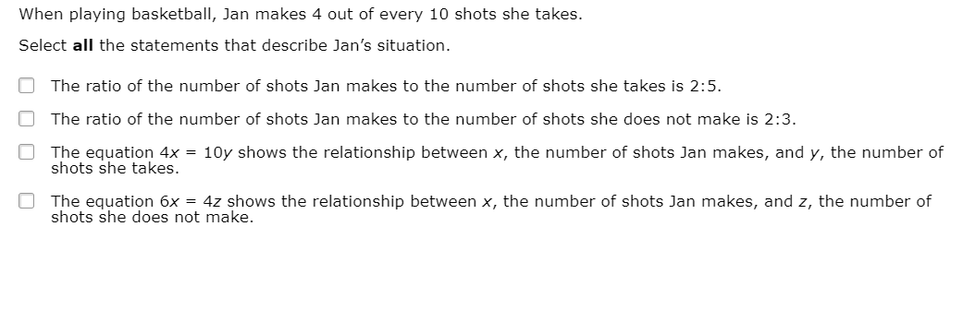

**4.**