Quadratics in Intercept Form Name ______________________________________
Algebra 1H Date _______________________Per_____________

- Recall that there are three forms quadratic functions can be given in:

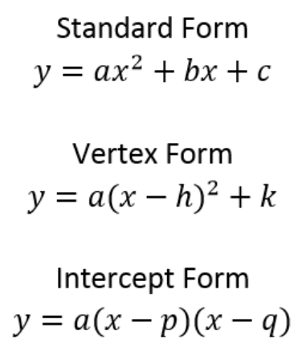

- Thus far you have mastered standard form and vertex form.

- Why do you think intercept form is called intercept form? What do you think the variables p and q represent?

- Go to desmos.com graphing calculator and graph the following four functions. Take note of the relationship between the vertex and the intercepts of each graph.
$$y=-(x+1)(x-3)$$
$$y=2(x-2)(x-5)$$
$$y=-\frac{1}{2}(x+5) (x+10)$$
$$y=(x-9)(x-1)$$

- What information is given in intercept form? How can this help us graph the parabola by hand?

- What information do we still need to complete the graph of the parabola?

- Based on your answers to #3 and #4, develop a strategy for graphing a quadratic function given in intercept form by hand.

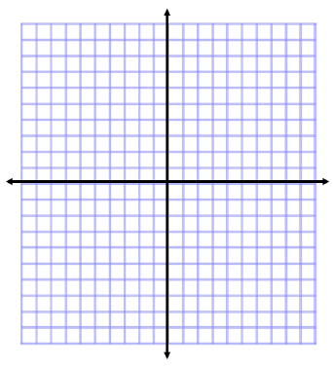
- Using the strategy you developed in #5, identify the vertex, axis of symmetry, domain and range of the following quadratic function, then graph the function. Then, verify your graph by graphing the function in desmos.

$$y=-(x-3)(x+6)$$

- Write a quadratic function in intercept form that opens down and has intercepts (7,0) and (-2,0). (Hint - there is more than one possible equation that satisfies these conditions!)

- How are standard form and intercept form connected?

- Using the digits 0 to 9 at most one time each, fill in the boxes to create three equations that produce the exact same parabola. This will take a bit of trial and error!

